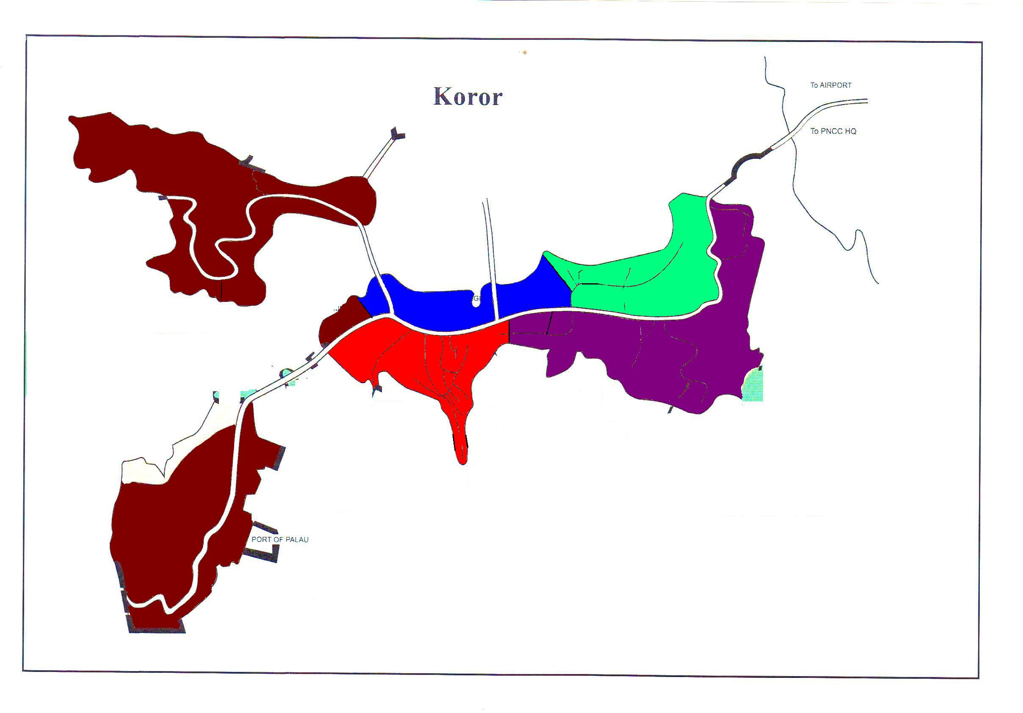

1
2
3
4
5&6
7
8
9&10
11&12
13&14
15
16
17
18&19
20
Blue Bay Gas Station
Surangel
G. B. Harris Elementary School

